1. a. P(J|G) = P(J|G, I) and P(M|G, B, I) = P(M|G, B, I, J) are asserted by the network structure.

b. P(B, I, M’, G, J) = P(B) x P(I|B, M’) x P(M’) x P(G|B, I, M’) x P(J|G)

= 0.9 x 0.5 x 0.9 x 0.8 x 0.9 = 0.2916

c. P(J|B, I, M) = ∑G’ P(J, B, I, M, G’) / ∑J’, G’ P(J’, B, I, M, G’)

= ∑G’ P(B) x P(M) x P(I|B,M) x P(G’|B, I, M) x P(J|G’) / ∑J’, G’ P(B) x P(M) x P(I|B,M) x P(G’|B, I, M) x P(J’|G’)

= P(B) x P(M) x P(I|B,M) x ∑G’ P(G’|B, I, M) x P(J|G’) / P(B) x P(M) x P(I|B,M) x ∑G’ P(G’|B, I, M) x ∑J’ P(J’|G’)

= ∑G’ P(G’|B, I, M) x P(J|G’) / ∑G’ P(G’|B, I, M) x ∑J’ P(J’|G’)

= 0.9 x 0.9 + 0.1 x 0 / 0.9 x 0.1 + 0.1 x 0 + 0.9 x 0.9 + 0.1 x 1

= 0.81 / 0.09 + 0.81 + 0.1

= 0.81 / 1

= 0.81

d. G is context – specifically independent of B and M given I is false. This is because a person cannot be found guilty if they have not been indicted, and this is true regardless of whether or not the law has been broken or the prosecutor is politically motivated.

e.

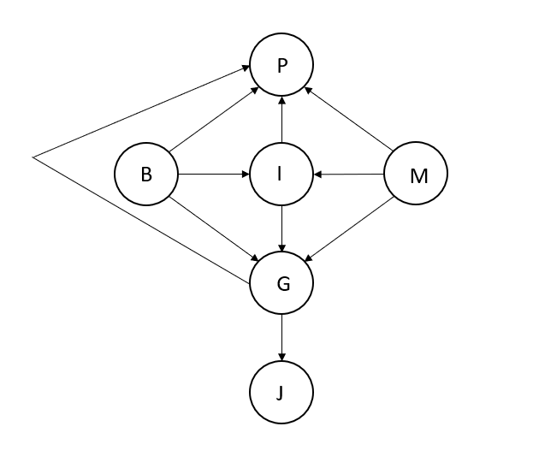

G, I, B, and M are made parents of P. This is because whether or not the person has been indicted, broken the law, found guilty, and/or judged by a politically motivated prosecutor all effect whether or not they receive a presidential pardon. J has been made a parent of P, because whether or not the person is sent to jail is the only other variable that can be affected by a presidential pardon.

1. a.

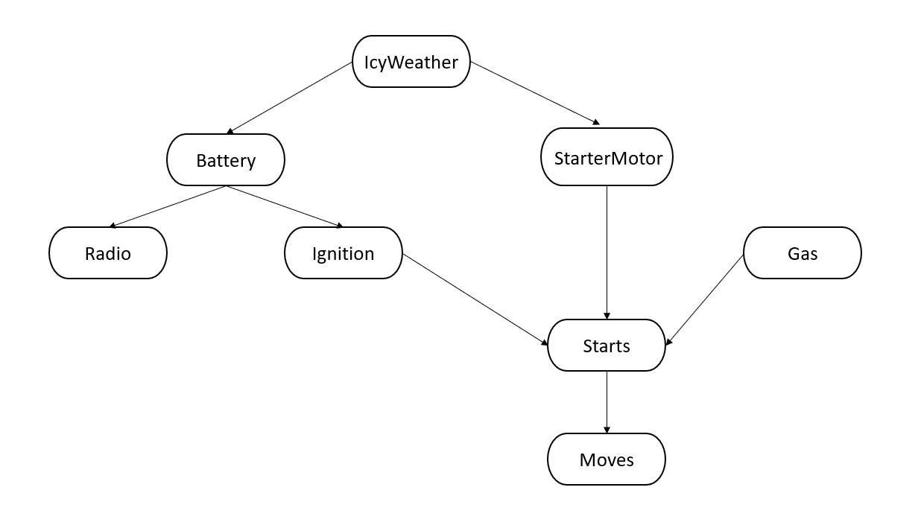

b. 28 – 1 = 256 – 1 = 255 independent values

1. a. Burglary and Evidence are independent if no evidence is observed.

Proof by numerical semantics:

P(B, E) = P(B|Parents of Burglary) X P(E|Parents of Earthquake)

= P(B) X P(E) [Burglary and Earthquake have no parents]

Proof by topological semantics:

Each variable is conditionally independent of variables that are not its dependents. Burglary is not a child of Earthquake or vice versa. Therefore, Burglary and Earthquake are independent.

b. Let us take the equation:

P(B, E|A) = P(B|A) x P(E|A)

P(A) = P(A|B, E) x P(B) x P(E) + P(A|B, E’) x P(B) x P(E’) + P(A|B’, E) x P(B’) x P(E) + P(A|B’, E’) x P(B’) x P(E’)

= 0.95 x 0.001 x 0.002 + 0.94 x 0.001 x 0.998 + 0.29 x 0.999 x 0.002 + 0.001 x 0.999 x 0.998

= 0.0016

P(B|A) = [P(A|B) x P(B) ] / P(A) = [P(A|B, E) x P(B) x P(E) + P(A|B, E’) x P(B) x P(E’)] / P(A)

= (0.95 x 0.001 x 0.002 + 0.94 x 0.001 x 0.998) / 0.0016 = 0.586

P(E|A) = P(A|E) / P(A) = [P(A, E|B) x P(B) + P(A,E|B’) x P(B’)] / P(A)

= [P(A|B, E) x P(B) X P(E) + P(A|B’, E) x P(B’) X P(E)] / P(A)

= (0.95 x 0.001 x 0.002 + 0.29 x 0.999 x 0.002) / 0.0016 = 0.362

P(B|A) X P(E|A) = 0.586 X 0.362 = 0.212

P(B, E|A) = [P(A|B, E) X P(B, E)] / P(A) = (0.95 X 0.001 X 0.002) / 0.0016 = 0.0012

Therefore, P(B, E|A) ≠ P(B|A) x P(E|A). Therefore, if Alarm is true, then Burglary and Earthquake are not independent.

1. a. Network (c), because there is a diverging connection between each pair in Gfather, Gmother , and Gchild.

b. Network (a) provides the best description of the hypothesis. Network (b) is very similar to (a), but it allows for additional dependencies such as the handedness of the child depending directly on the handedness of the parents.

c. P(Gchild = I) = ∑gm, gf P(Gchild = I|gm, gf) x P(gm, gf)

= ∑gm, gf P(Gchild = I|gm, gf) x P(gm) x P(gf)

= (1-m) x q2 + 0.5 x q x (1-q) + 0.5 x (1-q) x q + m x (1-q)2

= q2 – mq2 + q – q2 + m – 2mq + mq2

= q +m – 2mq